Workshop “Einführung in Methoden der modernen Kausalanalyse”

Exercise on “Selection on unobservables: Instrumental variable (IV) estimator”

Prof. Dr. Michael Gebel

Data: Socio-economic panel (SOEP) 2007; students’ version; identifying numbers have been removed

Sample: SOEP samples A-F, persons aged 20 to 60 who are employed at the date of the interview in 2007 and who receive a wage; all apprentices/pupils/students excluded

Treatment: college degree (university degree, technical college degree; CASMIN 3ab) versus no college degree (all the remaining education groups; CASMIN1+2); based on retrospective questions about the highest education degree obtained (CASMIN scale)

Outcome: hourly wage

Control variables and potential instrumental variables:
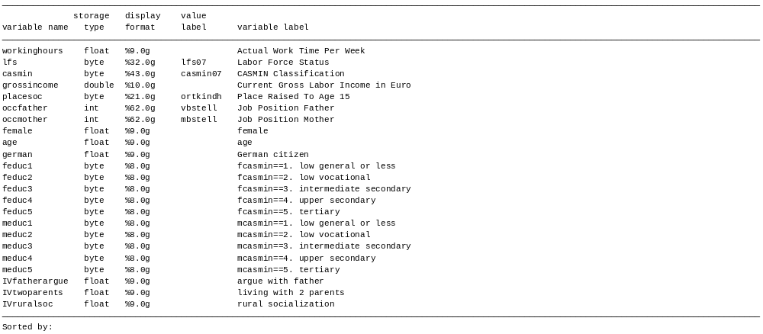
Exercises

1. Choose the IV “IVruralsoc”. Implement the classical IV estimator both using the ivregress command and by hand. Discuss the validity of the two basic IV assumptions.

2. Choose the IV “IVfatherargue”. Implement the classical IV estimator using the ivregress command. Interpret the results.

3. Choose the IV “IVtwoparents”. Implement the classical IV estimator using the ivregress command. Control additionally for father’s education. Does it make sense to include this control variable?

